

Contact: Soma Lisa Choudhury FOR IMMEDIATE RELEASE
Tel: 212-334-6865
Email: soma@leelany.com

SHRIVAN NARRESH: AQUATIC PRISM RESORT 2010 COLLECTION
AQUATIC PRISM: Search For The Essence of The Feminine Form

New York, NY-July 14, 2010. India’s first luxury beachwear brand SHRIVAN NARRESH has launched a new collection: Aquatic Prism RESORT 2010. Inspired by the earthy crystals, the collection reveals the new feminine form as sharp and luminous. The line redefines the concept of positive and negative with bold bikinis, jewel-detailed one-piece suits and Crystallized Swarovski necklaces.

Aquatic Prism fuses the mineral world with the human body by using soft cotton jersey and lycra in a mix of grays, deep blue, bright oranges, pinks and yellows. Stitch-free and handcrafted beachwear, along with futuristic bikinis show the unique signature style of SHRIVAN NARRESH that is bold, confidant and sophisticated. The bandeau top bikinis with flawless lines and jewels add a perfect glamour to beachwear, while geometric pareos complement the elegant look. With its approach of treating the human form as a prism, this collection will bring the beach style into a new level.
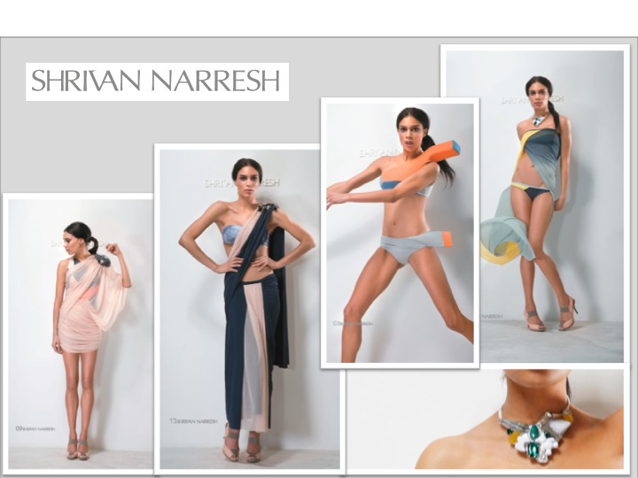

For additional information, please contact Soma Lisa Choudhury at 212-334-6865, or email soma@leelany.com. LEELA, 580 Broadway Suite 711 New York, NY 10012

